Course Name | ITD 2313 – Script Programming
Instructor | Rene Hurst
Student Name | Pete Fuentez
Due date | Oct 27 by 11:59 pm
Grade | Put grade earned here
Grading Comments | Put instructor comments here

Week 8 - Scripting Projects Assignment
Page 163 - 164
Project # 3
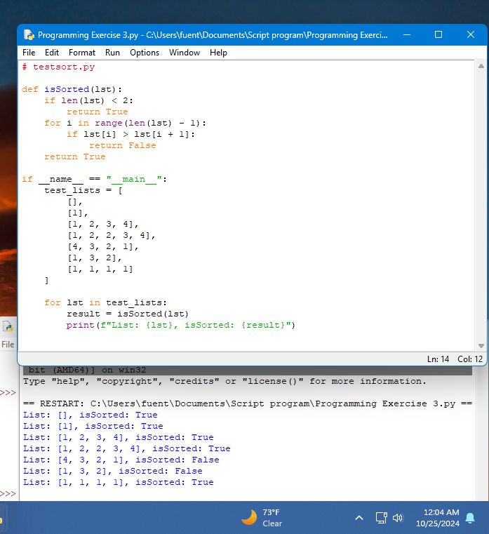
Project # 7
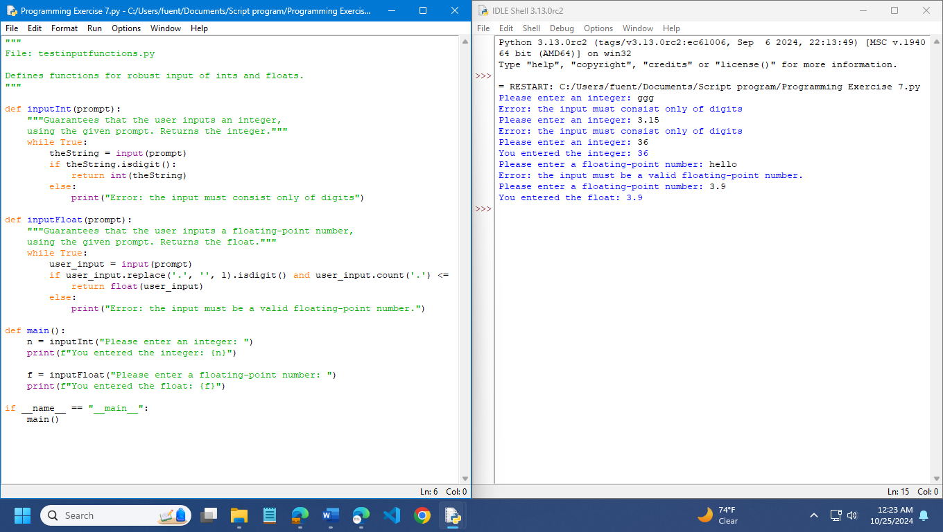

Chapter 7
Page 187
Project # 6 